**Lab no: 10**

**Lab task no: 1**

**Code:**

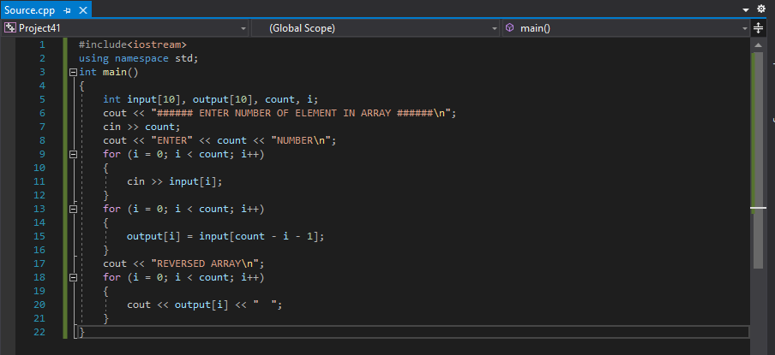

**Output:**

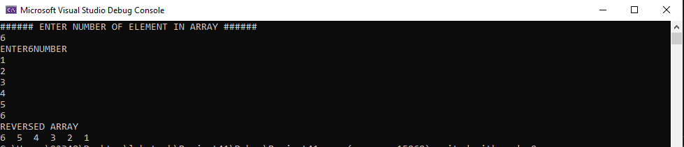

**Lab task no: 2**

**Code:**

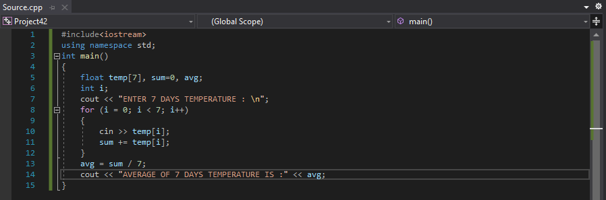

**Output:**

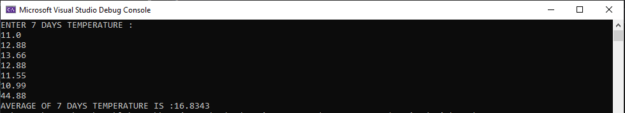

**Lab task no: 3**

**Code:**

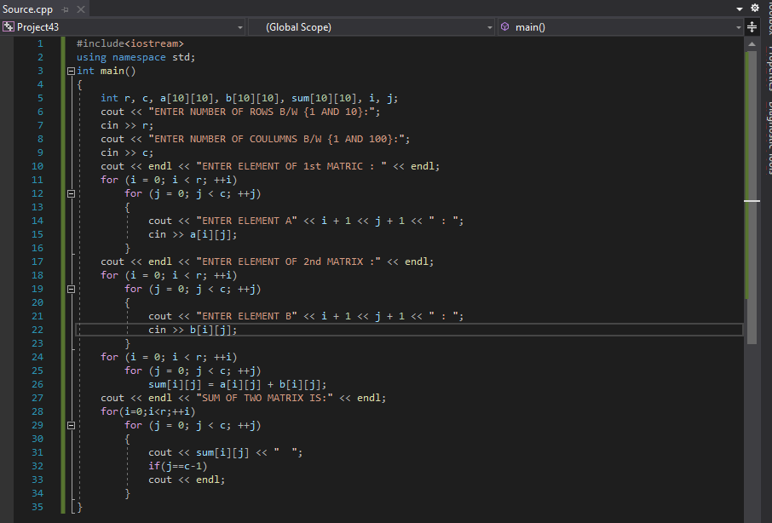

**Output:**

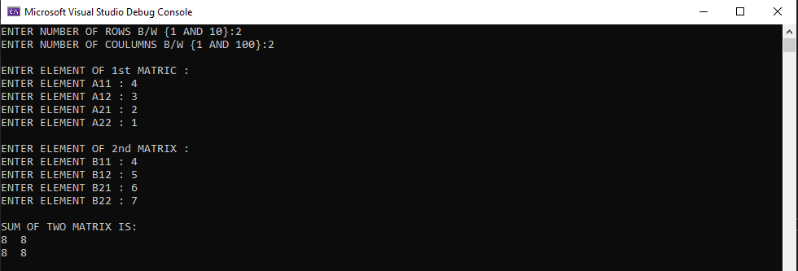

**Lab task no: 4**

**Code:**

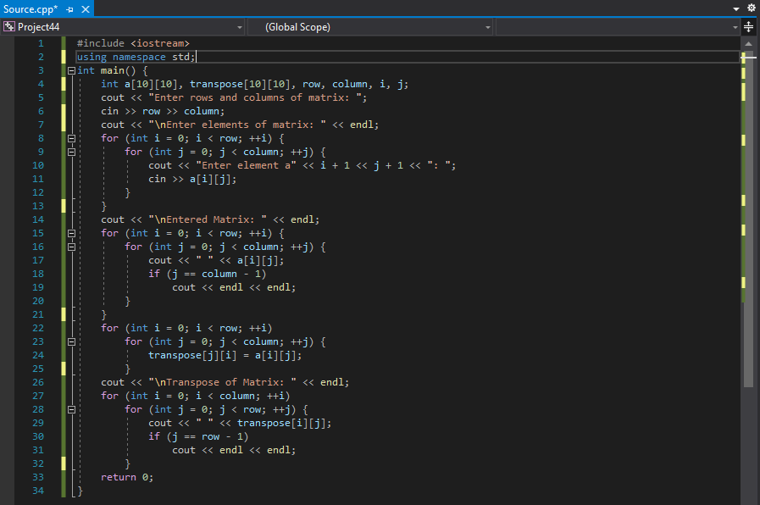

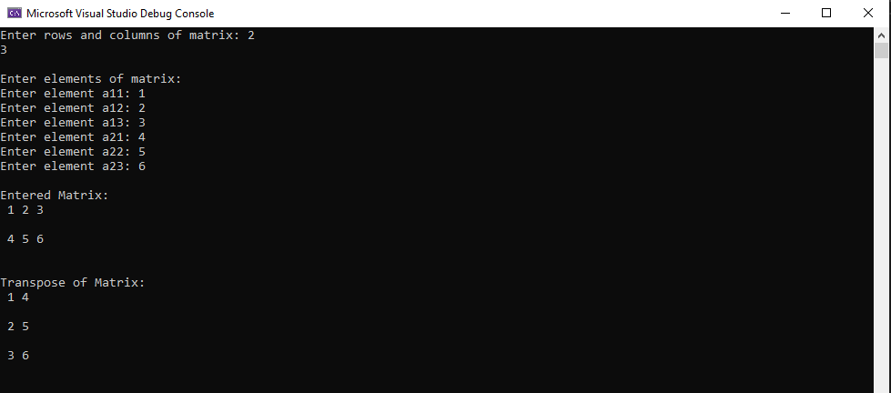**Output:**

**Lab task no: 5**

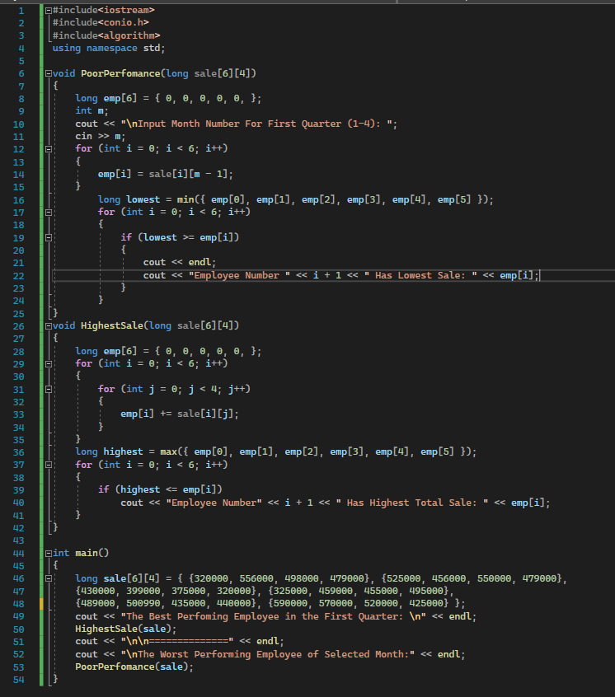**Code:**

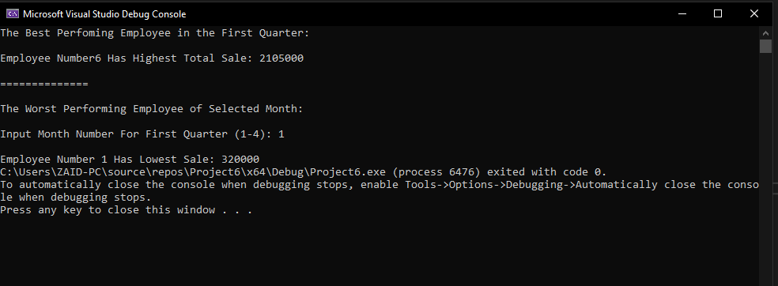**Output**

PROGRAM 1

#include<iostream>

using namespace std;

int main()

{

int xyz [3]; //={19,20,21};

xyz[0]=109;

xyz[1]=300;

xyz[2]=400;

cout<<"Array Element OF xyz[0] : "<<xyz[0]<<endl;

cout<<"Array Element OF xyz[1] : "<<xyz[1]<<endl;

cout<<"Array Element OF xyz[2] : "<<xyz[2]<<endl;

cout<<"Address Of First Value Is : "<<xyz<<endl;

cout<<"Address Of First Value Is : "<<&xyz[1]<<endl;

cout<<"Address Of First Value Is : "<<&xyz[2]<<endl;

}

PROGRAM 2

#include<iostream>

using namespace std;

int main()

{

int xyz [5];

cout<<"Entered values of the array : "<<endl;

for(int index = 0;index<=4;index++)

{

cin>>xyz[index];

}

cout<<"Entered values are"<<endl;

for(int index = 0;index<=4;index++)

{

cout<<"Array Element OF xyz[] : "<<xyz[index]<<endl;

}

}

PROGRAM 3

SUM & AVG

PROGRAM 4

#include<iostream>

using namespace std;

int main()

{

int xyz [5];

int max=xyz[0];

cout<<"Entered values of the array : "<<endl;

for(int index = 0;index<=4;index++)

{

cin>>xyz[index];

}

cout<<"Entered values are"<<endl;

for(int index = 0;index<=4;index++)

{

cout<<"Array Element OF xyz[] : "<<xyz[index]<<endl;

}

for(int index=0;index<=4;index++)

{

max = ( max < xyz[index] ) ? xyz[index]:max;

}

cout << max <<endl;

int min=xyz[0];

for(int index=0;index<=4;index++)

{

min = ( min < xyz[index] ) ? min:xyz[index];

}

cout<<min;

}

program

#include<iostream>

#include<cstdlib>

#include<time.h>

using namespace std;

int main()

{

int xyz [5];

int max=xyz[0];

srand(time(0));

cout<<"Entered values of the array : "<<endl;

for(int index = 0;index<=4;index++)

{

xyz[index]=(rand()%50)+1;

}

cout<<"Entered values are"<<endl;

for(int index = 0;index<=4;index++)

{

cout<<"Array Element OF xyz[] : "<<xyz[index]<<endl;

}

for(int index=0;index<=4;index++)

{

max = ( max < xyz[index] ) ? xyz[index]:max;

}

cout << max <<endl;

int min=xyz[0];

for(int index=0;index<=4;index++)

{

min = ( min < xyz[index] ) ? min:xyz[index];

}

cout<<min;

}